DB Assignment # 4 : Reports

Date: 12/08/2019

Name of Team: Peak Performers

Members names ASC:

Al Barwany, Nawras

Gahramanova, Darya

Liburd, Kaley

Morino, Natalia

Sharif, Mahir Muhtasim

**SmallVille Reports**

1. List of all Sales Reps with their total number of orders sold, total number of units sold, highest, lowest, and average dollar value generated, grouped by Sales Rep, sorted by highest to lowest orders, units, and sales dollar value.

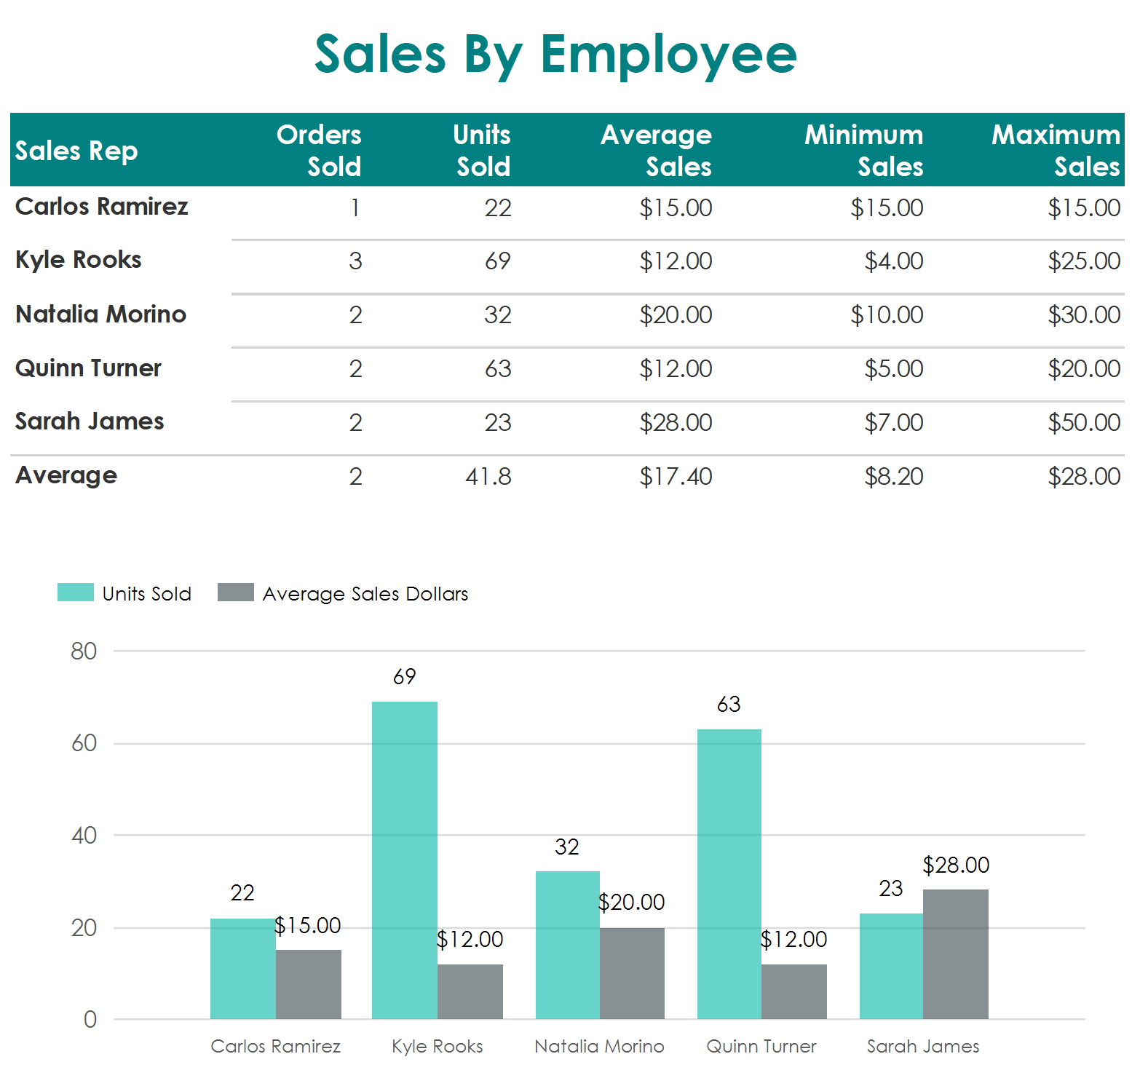

1. List of all employees and their current compensation due, grouped by their category, and sorted by highest salary

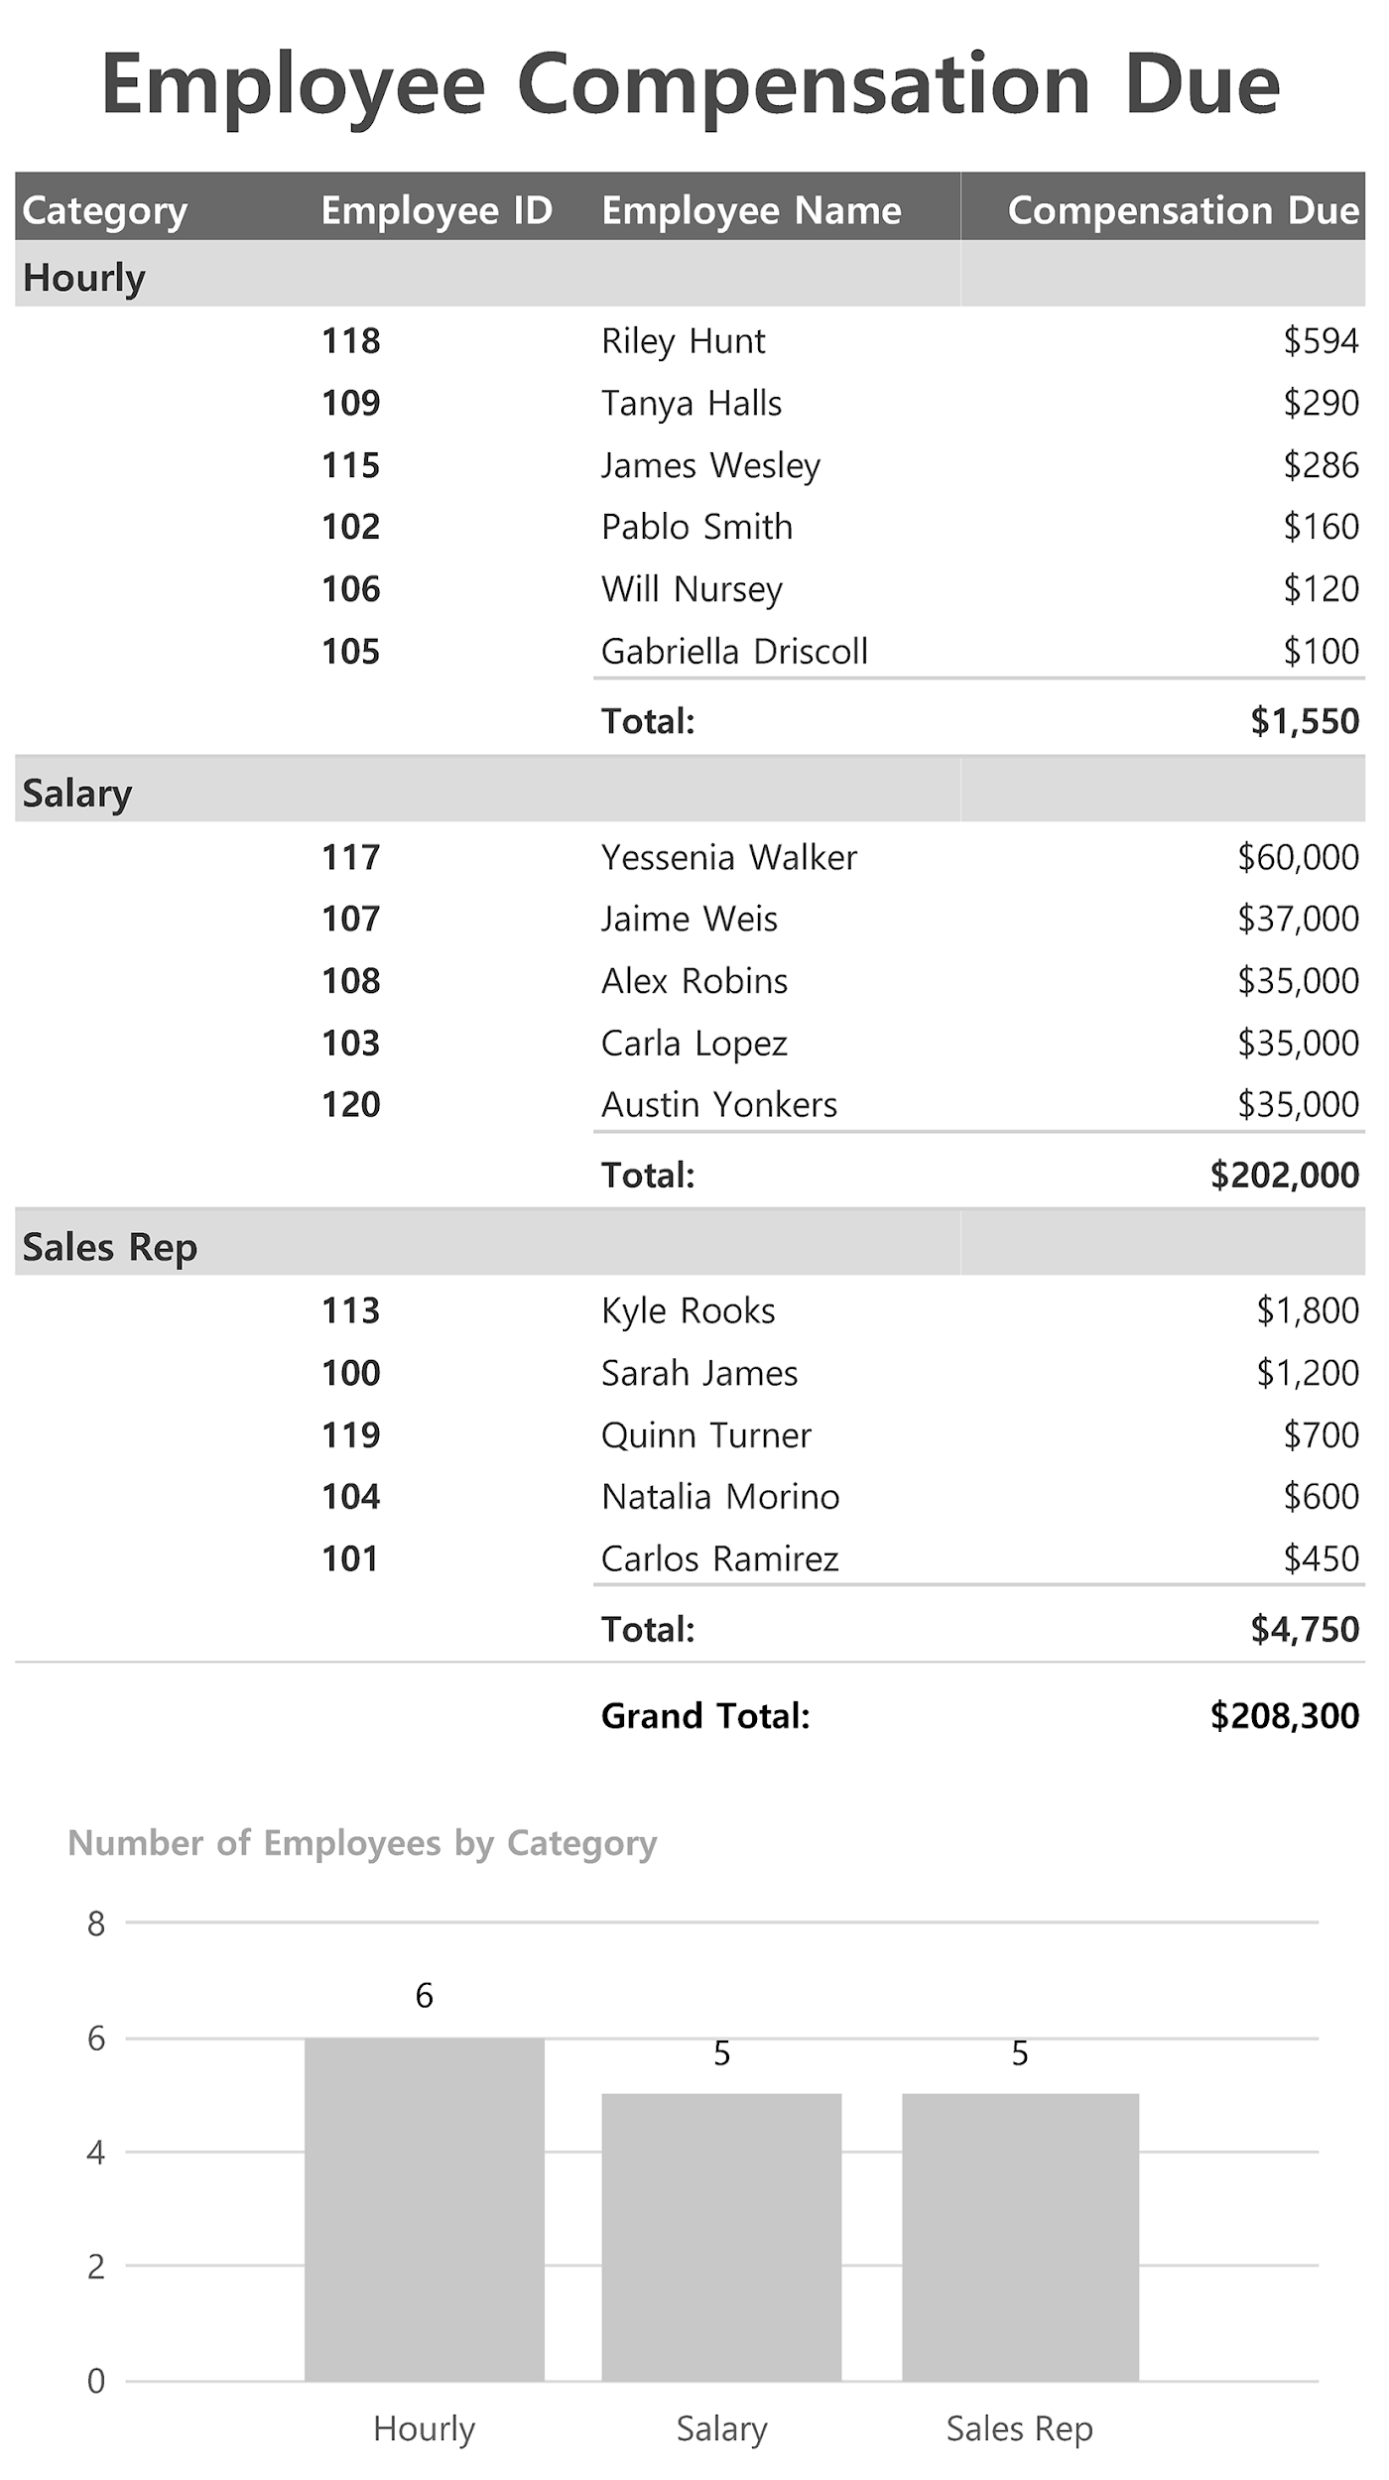

**Soccer Reports**

1. League needs a report listing all matches played so far this season. The list needs to include the teams playing in each match, the host field and goals scored by each team.

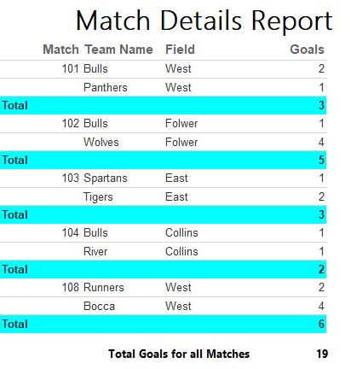

1. Create a team player roster SPROC with a parameter for team name.

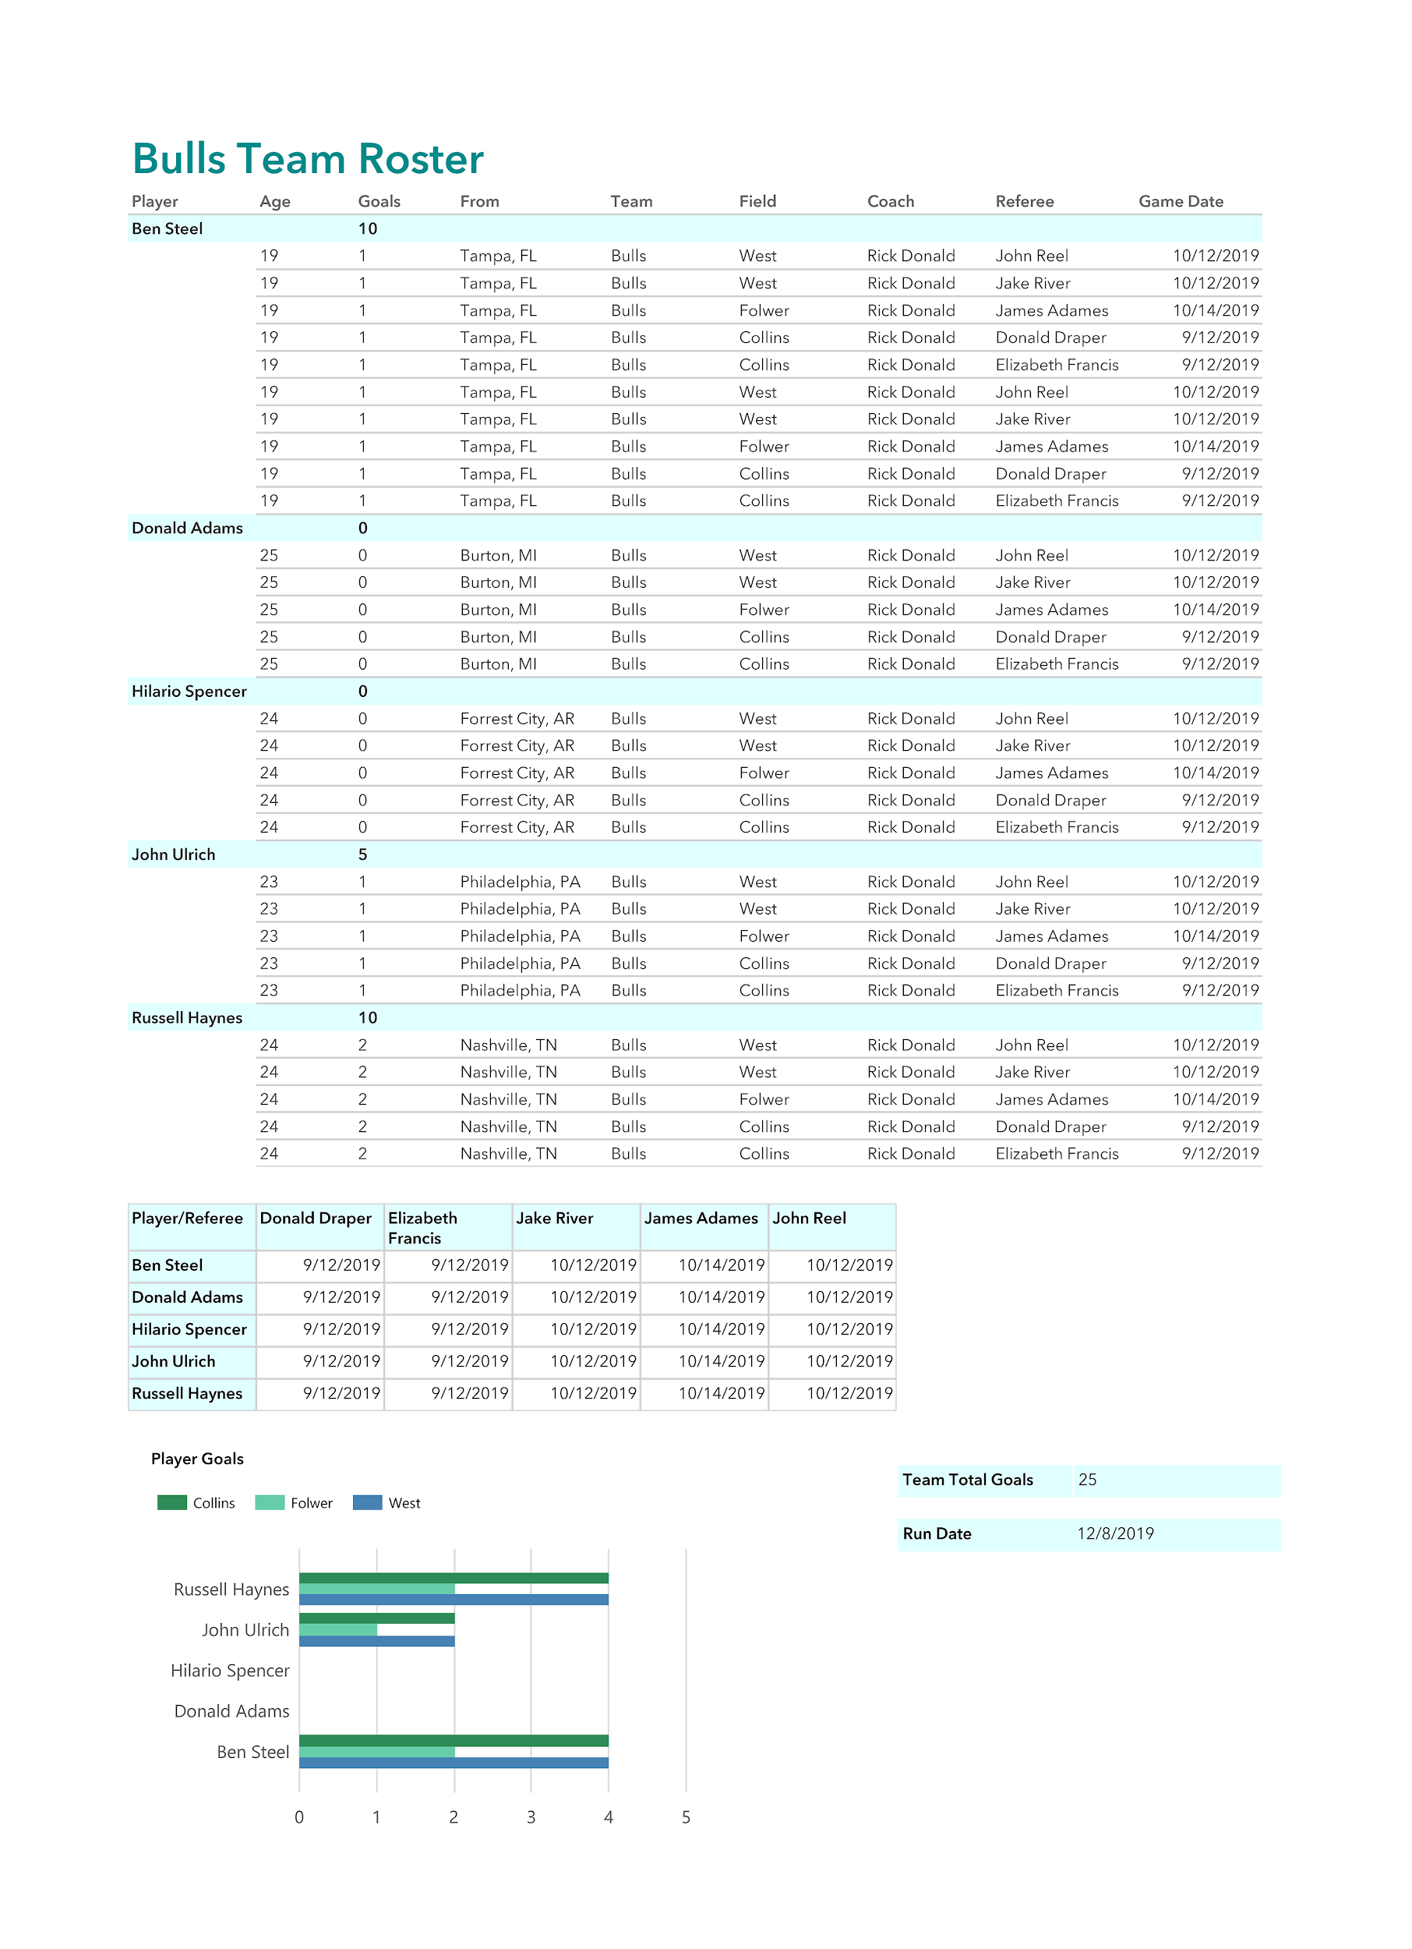

How the Parameter was set:

